Honor Committee Report
2018-2019

The Honor and Discipline Committee reports to the College each year about the nature of the cases it has heard, the judgments made, and the penalties it has determined. This report covers the meetings of the committee that reviewed cases during the 2018- 2019 school year. Following this report is a summary of disciplinary activity in the Dean’s office.

Part I: Honor Cases

- Two juniors were brought to the committee when a professor noted unusual similarities between their lab reports. Following the committee’s hearing and deliberations, the committee determined that one student violated the honor code by viewing the other student’s work on google drive and inserting some of the language into his own report. This student was sanctioned with failure in the course as well as mandatory completion of an educational tutorial about academic integrity. Because the other student did not knowingly provide access to his work, he was not found responsible for violating the honor code.

- A junior was brought to the committee when a professor grew concerned about the fact that large portions of a student’s work on several problems appeared to be nearly identical to those included the solution sets provided in a previous semester. Following the hearing and deliberation, the committee found the student’s explanation of how he produced his work (studying, re-writing notes, rote memorization) to be a credible explanation for the evidence. The student was found not responsible for violating the honor code.

- Three first year students, 1 junior, and 1 senior were brought to the committee when the professor grew concerns that the students were asking and providing each other with help on an assignment for which that kind of assistance was explicitly forbidden. After the hearing and deliberations, the committee found all 5 students responsible for violating the honor code. Because the collaboration was minimal and there was some confusion about the kind of peer assistance that was allowable, the students were sanctioned with failure in the assignment rather than failure in the course. In addition, all students were required to complete the educational tutorial.

- Two first year students were brought to the committee when a professor and TA identified several sections of computer code that were identical in their lab reports. During the hearing, the students reported that a TA for the class provided one student with specific coding instructions while the other student was sitting nearby, and within earshot. At a later point, the TA went to the front of the room and wrote some code on the board. Following the hearing and deliberations, the committee found it credible that the marked similarities found between the students’ code could be attributed to the highly specific/explicit help provided by the TA. Neither student was found responsible for violating the honor code.

- A junior and a senior were brought to the committee when a professor identified several sections of their lab reports that were highly similar to each other. During the hearing, the senior acknowledged that he found an earlier draft of the junior’s paper in the printer at the library, and used portions of that work to write his lab report. Following the hearing and deliberations, the committee found the senior responsible for violating the Honor Code and issued a sanction of failure in the course. The junior was found not responsible.

- A first year student was brought to the committee when the professor identified several sections of the student’s paper that seemed to be written in a different authorial voice, as well as some sentences that were placed in quotes, but without any attribution. When the professor Googled the concerning sections, he found that they linked to a SparkNotes entry online, and both the structure and content of the paper were taken directly from the online source. After the hearing and deliberation process, the committee found the student responsible for violating the honor code. Typically a violation of this type would result in failure in the course, but the committee recommended the lighter sanction of failure in the assignment when they learned that the student had no no prior experience or training in citation. In addition to failure in the assignment, the committee also required completion of an educational tutorial about academic integrity.

- A junior was brought to the committee when the course instructor notice that more than one essay contained information taken directly from online sources, without citation or attribution. In the deliberation phase of the hearing, committee members found the student responsible for violating the Honor Code and agreed on a sanction of failure in the course, plus mandatory completion of an online educational tutorial.

- A junior was brought to the committee when a lab instructor discovered that the student’s lab report was identical to that of another student assignment from a previous year. Following the hearing and deliberations, the committee found the student responsible for violating the honor code. The student received a sanction of failure in the course.

- A senior was brought to the committee when a professor noted numerous instances in which the student did not cite or attribute others’ work in a paper. Following the hearing and deliberations, the committee found the student responsible for violating the honor code and agreed on a sanction of failure in the course.

- Two juniors and a sophomore were brought to the committee when the professor noticed that the students had produced strikingly similar solutions on a problem set, along with similar omissions and errors. Following the hearing and deliberations, the committee found two of the students responsible for violating the honor code by collaborating on work that was designed to be completed independently, agreed on a sanction of failure in the assignment. The committee did not find a preponderance of evidence to suggest that the third student had collaborated; this student was not found responsible.

- A junior was brought to the honor committee when the professor suspected that the student was dishonest about when she completed and submitted a paper. Specifically, the professor noted that when he opened the student’s attachment, it was an incomplete draft; he asked the student to re-submit the final version along with a note confirming that the student did not add anything addition to the paper after the deadline. The student submitted the final version several days letter, along with the confirmation. A review of “version history,” however, revealed that the student had continued to work on the paper after the deadline. Following the hearing and deliberations, the committee found the students responsible for violating the honor code by being dishonest about when the work was completed, agreed on a sanction of failure in the course.

- Two seniors were brought to the honor committee when the professor noted unusual similarities between their completed homework assignments, as well as similarities between their work and the answer key from a previous semester. Following the hearing and deliberations, the committee found one student responsible for violating the honor code by using a previous year’s problem set to complete his work, and by inappropriately sharing his work with the other student, and was given a sanction of the failure in the course plus completion of the educational tutorial. The other student was found responsible for inappropriate collaboration and given a sanction of failure in the course.

- Two first year students were brought to the honor committee when the professor noticed that their midterms included several sections that were highly similar to each other. During the hearing, one student acknowledged that she copied portions of the other’s exam without that student’s knowledge. This student was found responsible for violating the honor code and sanctioned with failure in the course. The other student was not found responsible.

- A first year student was brought to the committee when another student raised concerned about that student potentially cheating on an exam to the professor. After reviewing all of the evidence, the hearing panel did not find a preponderance of evidence to suggest that the student copied responses from other students and therefore did not find her responsible for violating the honor code.

- A junior was brought to the committee when the professor suspected that the student had corrected answers on a graded exam in order to present them as grading errors and get additional points. Following the hearing and deliberations, the committee found the student responsible for violating the honor code by misrepresenting work to the professor. Because this was the student’s second honor code violation, they agreed on a sanction of failure in the course plus disciplinary probation until graduation. It is worth noting that some members were considering a more serious sanction of suspension before ultimately deciding on the lesser sanction. This underscores their sense of the severity of this violation.

- A first year student was brought to the honor committee when the professor identified several sentences within a paper containing factual information without any citation in the text, as well as some sections that appeared to be taken from online sources without any attribution. In the deliberation phase of the hearing, the committee found the student responsible for violating the honor code, and agreed on a sanction of failure in the assignment and completion of the educational tutorial. They chose a lighter sanction because they were compelled by the student’s explanation that they did not have sufficient experience or training in citation prior to arriving on campus.

- A senior and a sophomore were brought to the committee when a professor noticed that several sections of their assignments were identical to each other. During the hearing, the senior acknowledged that he looked at the sophomore’s computer screen during a lab session without his knowledge and copied material from that student’s program into his own. Following the hearing and deliberations, the committee found the senior responsible for violating the honor code and agreed on a sanction of failure in the course. The sophomore was not found responsible.

- A junior was brought to the committee when the professor noticed that portions of the student’s paper did not seem to be written in the student’s voice, and seemed too general given the specific thesis of your paper. When the professor Googled the phrasing, he found that 70-80% of the student’s paper came directly from 2 online sources, without citation. Following the Honor Committee’s hearing and deliberations, the committee determined that the student violated the honor code and agreed on a sanction of failure in the course.

- A junior was brought to the committee when a TA noticed that some of the language in the student problem sets was very similar to the language used in a solution set written by the professor, designed to be provided to students after their work has been submitted. During the hearing, the student acknowledged that they copied portions of 2 problem sets they had downloaded 2 years earlier. Following the hearing and deliberations, the committee found the student responsible for violating the honor code and agreed on a sanction of failure in the course.

- Two first year students were brought to the committee when a professor identified several parts of a take-home midterm (including errors) that were nearly identical to each other. During the hearing, both students acknowledged that they collaborated on the midterm. Following the hearing and deliberations, the committee found both students responsible for violating the honor code and agreed on a sanction of failure in the course.

- Two sophomores were brought to the committee when a professor identified multiple sentences in a take-home exam that looked highly similar, including cases in which answers were incorrect in the same idiosyncratic manner. During the hearing, both students acknowledged that they collaborated with each other during the exam In the deliberation phase of the hearing, committee members found both students responsible for violating the honor code and agreed on a sanction of failure in the course.

- A sophomore was brought to the committee when a professor identified several portions of a final paper that seemed to be written in an unfamiliar style, and which did not fit within the style of the overall paper. A Google search revealed that the material came directly from an article available online. Upon further inspection, the professor found additional sections of the paper that were taken verbatim from the same online source without any attribution or citation. In the deliberation phase of the hearing, committee members found the student responsible for violating the honor code, and agreed on a sanction of failure in the course.

Part II: Summary of Honor Case Data

Figure 1: Findings of Responsibility Figure 2: Involved Students by Course Level
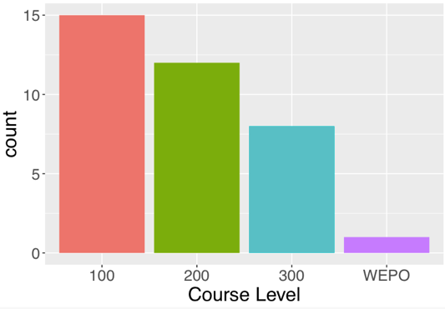
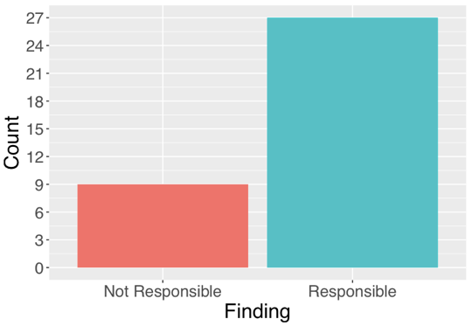

Figure 3: Involved Students by Course Department

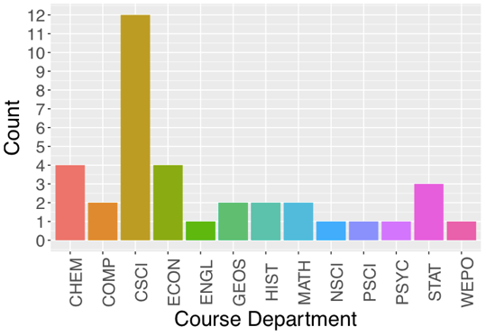

Figure 4: Involved Students by Course Division
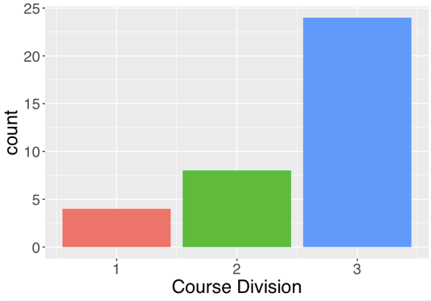

Figure 5: Involved Students by Class Year
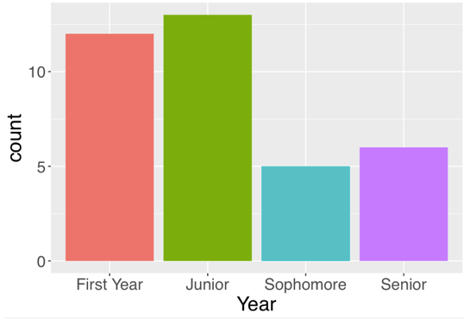

Part III: Faculty Survey Data on the Honor Code

At the end of the 2018-2019 academic year, the committee collected feedback from the College’s faculty on academic integrity practices and their experiences with the honor committee. Approximately one-third of faculty, evenly distributed by division, responded. Notable findings and recommendations for the committee are summarized below.

- Almost all faculty review academic integrity expectations for their courses at the start of the semester. Only half, though, review specific expectations for particular assignments. The committee encourages faculty to remind students of specific honor code expectations for each assignment, especially in courses where certain assignments may have different expectations around collaboration.
- Just over half (51.3%) of respondents had reported a violation of the honor code in their time at Williams, 91.5% of whom had cases proceed to a hearing. Almost all faculty expressed their approval of the reporting process. In the free-response section, some faculty asked for an online form for reporting or clearer information on who the faculty chair is and how to report. Others asked for an informal means to get advice from either the committee or other faculty without having to make a report. The committee will work on both these suggestions and reminds faculty that they may speak with the faculty chair for advice at any point without making a formal report. They may also consult other faculty so long as they do not reveal the identities or identifying information about the students in question, in line with applicable confidentiality policies and law.
- While a supermajority of faculty who had participated in honor hearings expressed satisfaction with the efficiency (81.5%) and fairness (85.2%) of the hearing process, some faculty expressed concern over the scheduling of hearings and the reasonableness of the committee’s decisions. Scheduling remains a persistent challenge for the committee and we will work to track and improve the report-to-completion timeline for this year's caseload. Additionally, some faculty asked for a set time in the hearing for them to respond to the student’s presented evidence, which the committee will now implement. Some faculty also expressed concern over the confidentiality of the hearing process. The committee will implement new training and a confidentiality agreement to reinforce the importance of this issue to its members.
- Amongst respondents, just under half (44.3%) said they have suspected a student of an honor code violation but not reported it. By far the most prevalent reasons for this were a perceived lack of evidence or the belief that informal methods of dealing with the violation would be easier. This result indicates that the committee must continue to devote attention to making the hearing process as transparent and accessible for faculty as possible.

Part IV: Disciplinary cases
For the 2018-2019 academic year, four students were suspended between one semester to two years along with disciplinary probation for violations of the College's Code of Conduct with regard to theft and property damage. Four students were placed on disciplinary probation due to violations involving harassment. An additional 172 students received warnings about minor violations related to unregistered parties, underage drinking, marijuana possession/use, disruption, copyright infringements, and property damage.

